LIBRARY MANAGEMENT SYSTEM

CLASS DIAGRAM

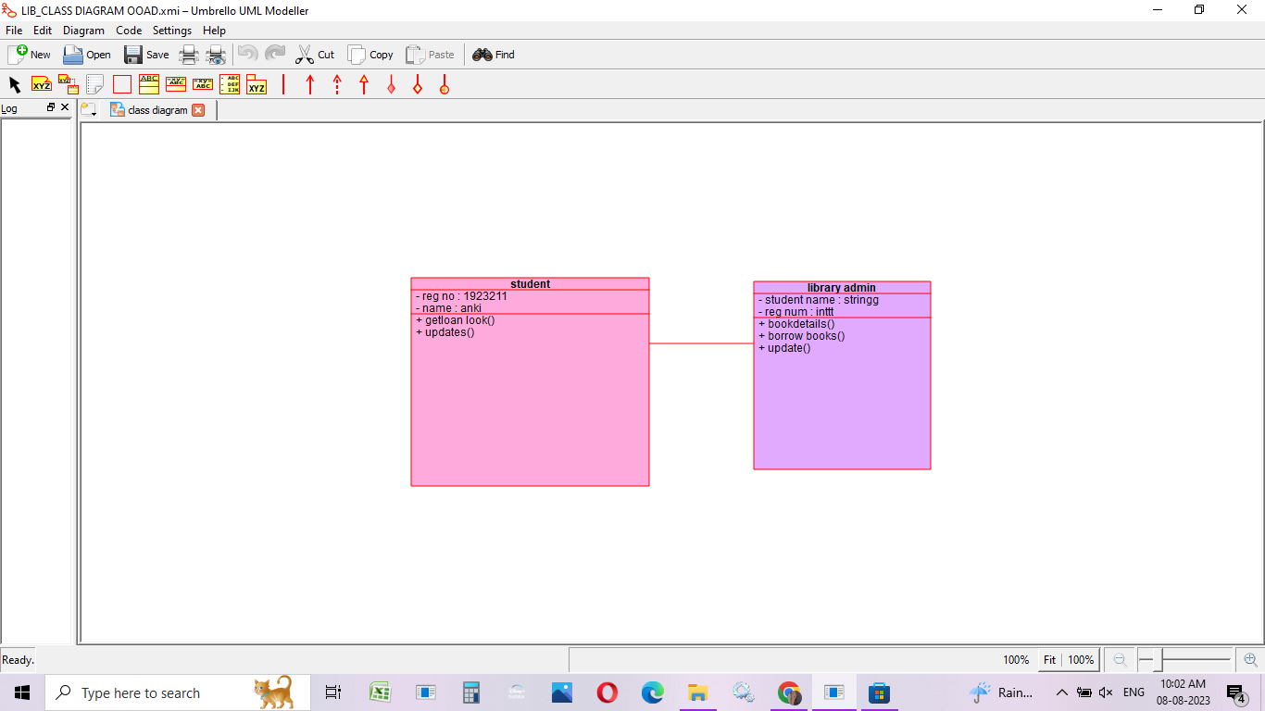

USE CASE DIAGRAM

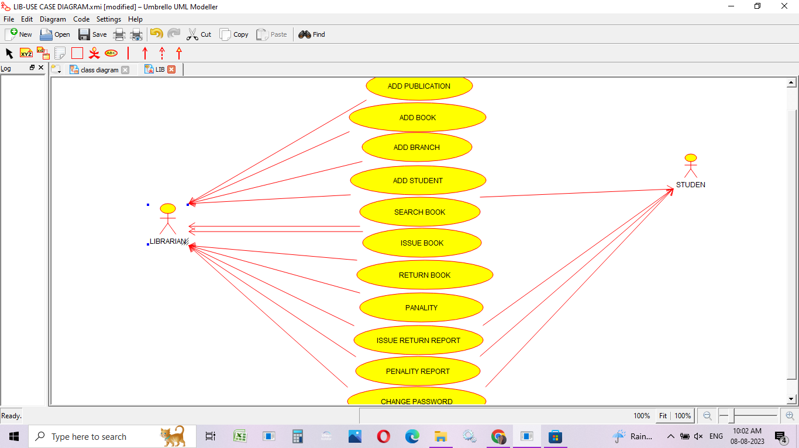

SEQUENCE DIAGRAM

